**Freedom Fighting 101 Interactive Display Board**

Assembly and game instructions

Materials:

* Freedom Fighting 101 Title PDF
* Freedom Fighting Helmets and Facemask PDF
* Velcro strips
* Foam board/cardboard
* Prizes (optional, e.g. stickers or buttons in support of Hong Kong)

Assembly Instructions:

1. Print out the PDFs for the (a) Title and (b) Helmets and face masks
2. Cut out the helmets, facemasks, Lin Pig, speech bubbles/instructions and title
3. Laminate the helmet and facemask cutouts and cut them out
4. Stick the title and helmets onto the foam board/cardboard
5. Stick velcro strips onto the edge of the helmets (i.e. beneath the words on it) and onto the back of the facemasks, such that the facemasks can be stick onto the helmet
6. Feel free to come up with more questions and answers

Reference photo for final product

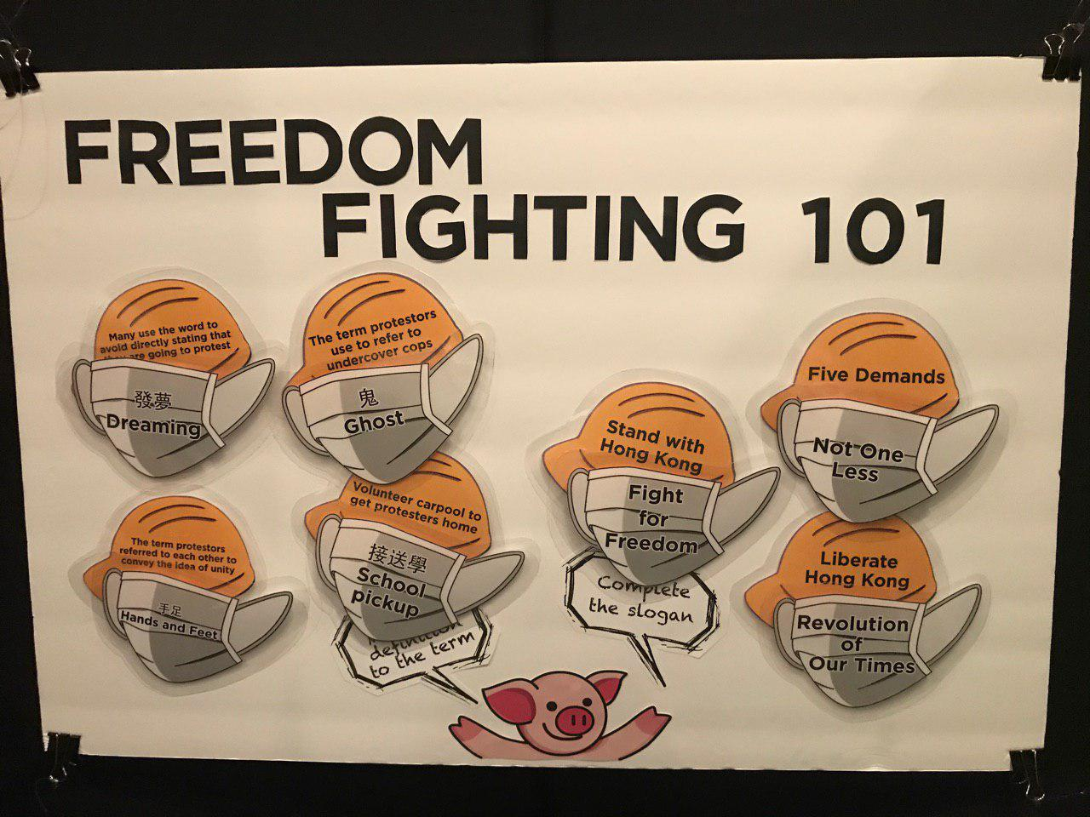

Game Instructions:

1. The player is presented with facemasks to match and stick to the corresponding helmets
2. Questions either pertain to (a) protest slogans in English and (b) definitions of “protest slang”
3. Regardless of whether a player matches the helmets and facemasks correctly, the game is meant to be a conversation starter so people learn more about the situation in Hong Kong
4. You may also consider offering prizes after a person has played the game (e.g. stickers or buttons showing solidarity with Hong Kong)